FirstName|LastName|Gender|Country|Age

Bulce|Abril|Female|United States|32

Mara|Hashimoto|Female|Great Britain|25

Khilip|Gent|Male|France|36

Pathleen|Hanner|Female|United States|25

Tereida|Magwood|Female|United States|58

IMPORT THE ABOVE DATA IN SAS

FirstName LastName Gender Country Age

Dulce Abril Female 'United States' 32

Mara Hashimoto Female 'Great Britain' 25

Philip Gent Male France 36

Kathleen Hanner Female 'United States' 25

Nereida Magwood Female 'United States' 58

IMPORT THE DATA IN SAS

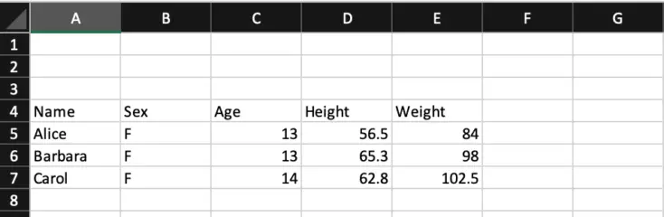

IMPORT THE ABOVE DATA IN SAS HAVING ONLY 2 OBSERVATIONS

3 QUESTIONS are given import the data by adding the first 2 questions in txt files and the 3rd question in excel file.

Upload the files in server file and folder

Finally import the sas dataset or tables\*/